PYTHON SYNTAX

Indentation in python

Indentation refers to spaces at the beginning of the line of code;

Unlike other programming languages, where most are only used to make the code more readable, in python, indentation is very important functionally;

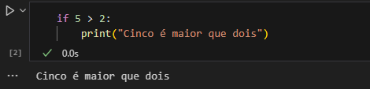In python, indentation is used to indicate a block of code;

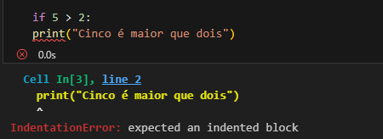Python will return an error if you forget the indentation!!

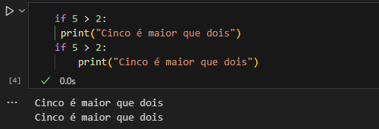As a programmer you are free to choose the number of spaces you want, but the most common is 4, however, you need at least 1;

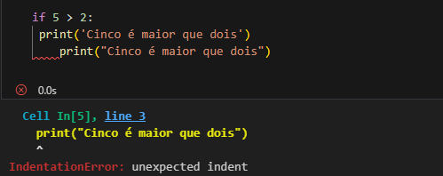Just remember that the number of spaces must be the same in each block of code, otherwise it will return an error!